Dice Project
This project uses a 555 astable circuit to provide the clock pulses for the 4017 counter.
The 555 astable circuit provides clock pulses at about 5kHz for the 4017 counter which has ten outputs (Q0 to Q9). Each output becomes high in turn as the clock pulses are received. Only six counts (Q0-Q5) are needed so Q6 is connected to reset. Appropriate outputs are combined with diodes to supply the LEDs: for example Q1, Q3 and Q5 are combined for LED A.
Press the push switch to 'throw' the dice: this makes the circuit rapidly cycle through the dice numbers so that an effectively random dice number is displayed by the LEDs when the push switch is released.
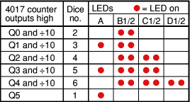
The dice sequence has been started at 2 so the ÷10 output can be used for LEDs B1 and B2, this saves diodes and simplifies the circuit. Pressing the push switch makes the disable input low so that counting occurs.

CIRCUIT DIAGRAM
