Simple Latched hand steady game
PROCESS
INPUT
OUTPUT

WIRES THYRISTOR BUZZER
LED

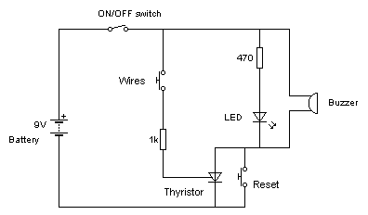

How it works:

Turn on the circuit using the on/off switch.
Touch the wire together (push switch) & a voltage goes to the gate of the thyristor (latching switch) turning it ON. The thyristor then switches on the LED & BUZZER. The outputs remain ON constantly until the reset button is pressed. The reset button short circuits the thyristor. The 470 resistor limits the amount of current the LED receives so it does not get damaged, same for the 1k protecting the thyristor
Artwork with silkscreen
Art work
PCB layout
